FIELD REPORT: Fields Art Center Report, 7/2/2013
Prepared by: | Larry Atchison

Parties Present | Organization | Email Address
Larry Atchison |  | atchison@lclark.edu

General Observation | - Focus of painting now on sculpture studios on level 1.  - Cooling for 209 being completed this week.  - Landscape subcontractor to replace pavers on south side 7/3.
Photos
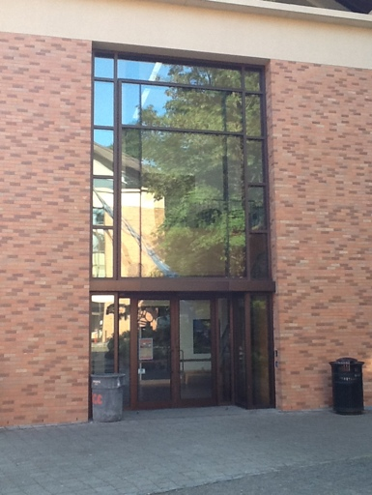  Glass replaced and cleaned. |  | 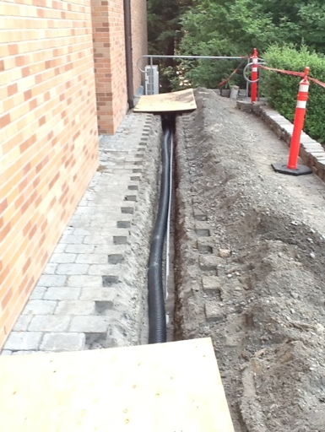  Outdoor unit for cooling computer lab in 209.
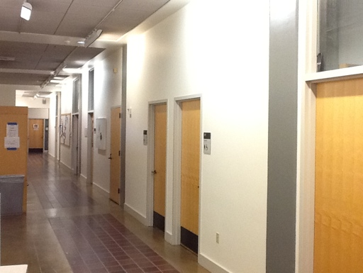  Interior corridor painting complete. |  | 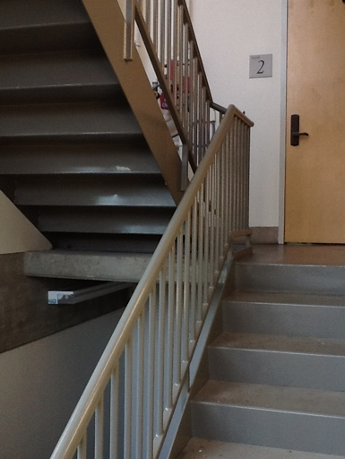  Stairwell painting in progress
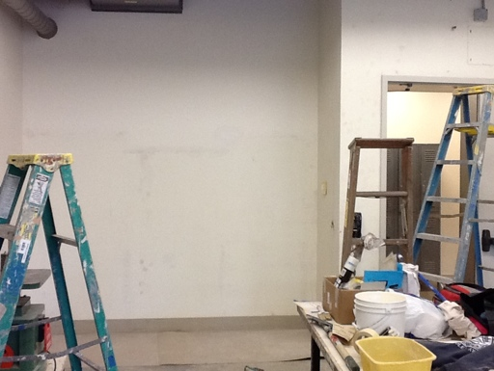  Prepping and repairing walls in 103. |  | 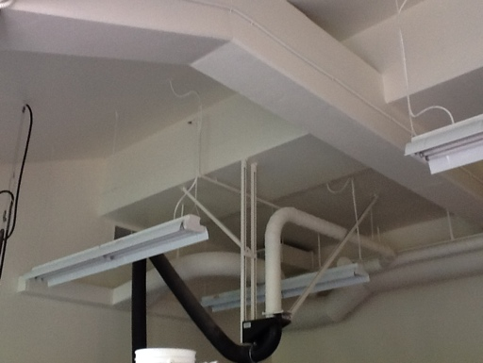  Ceiling in 102 painted white.
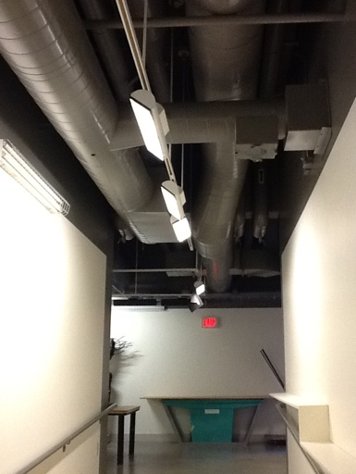
100 level corridor painted.

