FIELD REPORT: Forest Exhaust Fan Report, 7/16/2013
Prepared by: | Larry Atchison

Parties Present | Organization | Email Address
Larry Atchison |  | atchison@lclark.edu

General Observation | - Alder, Manzanita, and Juniper fan work in process. Moving to Spruce & Ponderosa later in the week. Tamarack work next week.
Photos
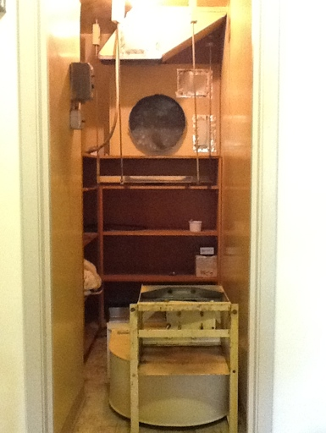  Unit removed in Alder for shafts to be re-worked. |  | 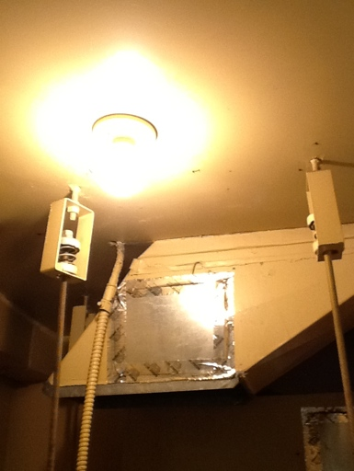  Old spring isolators

