FIELD REPORT: Olin Field Report, 8/15/2013
Prepared by: | Larry Atchison

Parties Present | Organization | Email Address

General Observation | - Finishing mechanical and electrical connections for lab equipment.  - Final completion by 8/23
Photos
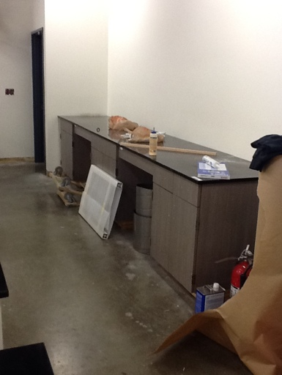  New casework on north wall to replace old hoods in 220 |  | 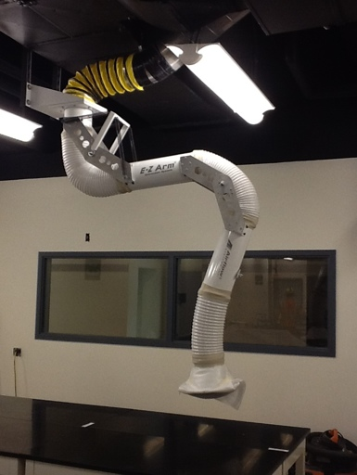  New articulated hoods for each work bench in 220
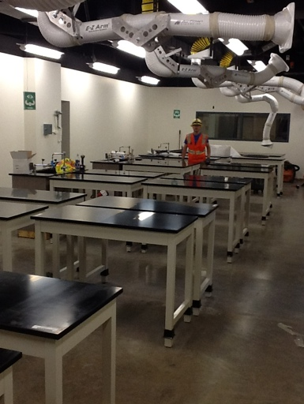  Portion wall between 215 & 220 removed. Window added to west corridor |  | 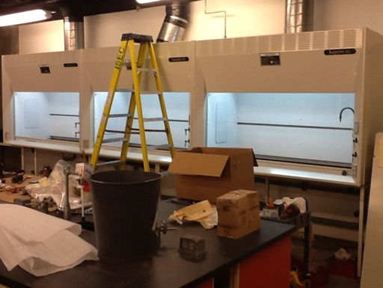  New hoods in 116
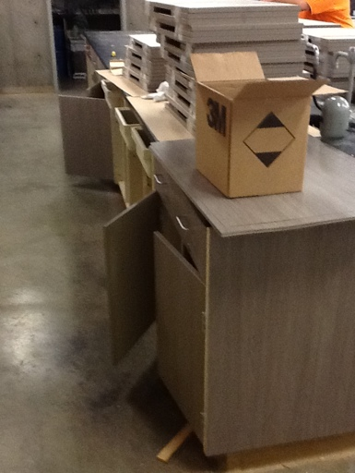  New door and drawer fronts in 116 |  | 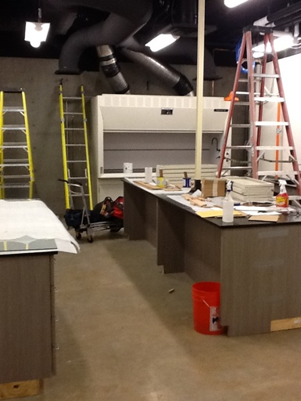  New chemistry research lab in 112
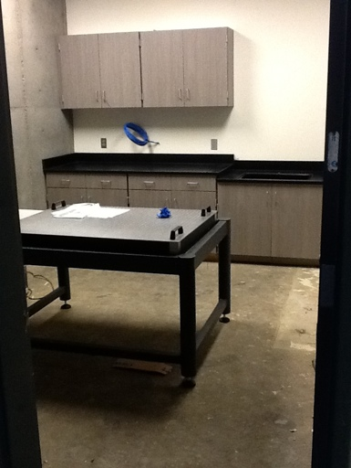  New chemistry research lab in 104 |  | 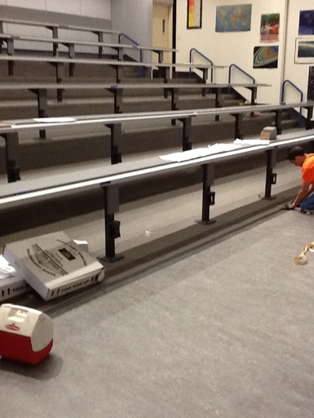  New flooring and benches for 204
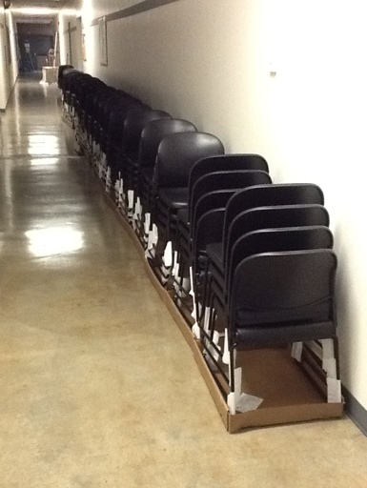
New seating for 204

