FIELD REPORT: Eldon Fix Track Report, 8/12/2013
Prepared by: | Larry Atchison

Parties Present | Organization | Email Address
Larry Atchison |  | atchison@lclark.edu

General Observation | - Striping complete today.  - New ramps in south D-zone still to complete.
Photos
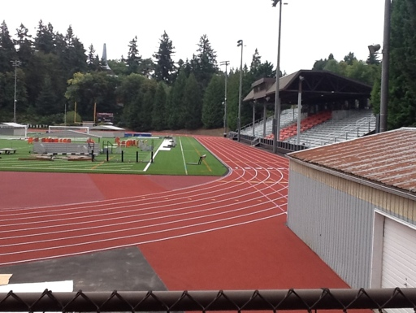  Track applied |  | 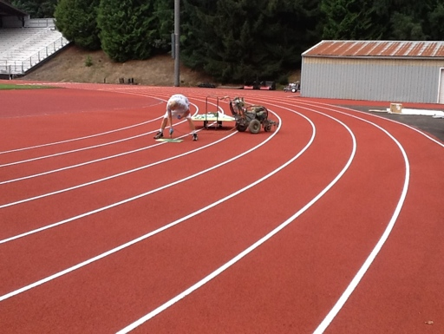  Striping finishes today
Different materials for track and D-zones for drainage requirements

