FIELD REPORT: Sewer, Run B, Report, 8/15/2013
Prepared by: | Larry Atchison

Parties Present | Organization | Email Address
Larry Atchison |  | atchison@lclark.edu

General Observation | - Testing of pipe complete.  - Will open Templeton to Manor path by end of the week
Photos
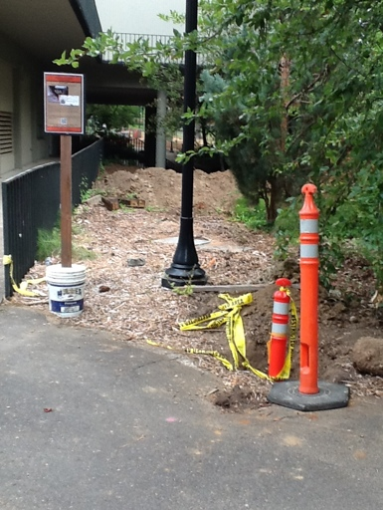  Piping complete, but need to replace valve near parking lot. |  | 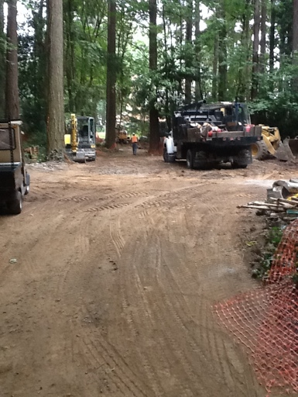  Pipe run complete without removal of trees.
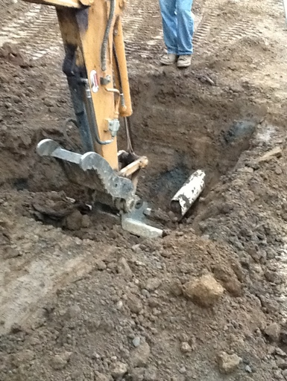  Repairing damaged storm line |  | 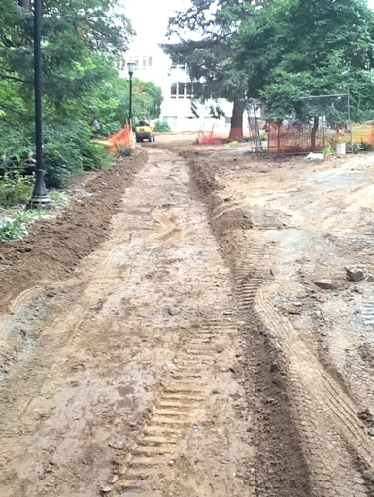  Grading for path replacement
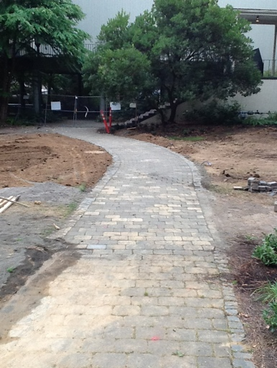  Path complete |  | 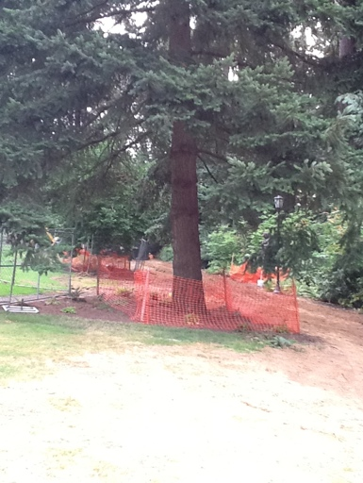  Tree protection in place

