SafeConnect Guest Access

- Set your wireless to use LC Wireless and then open a web browser. You will be redirected to the page below.
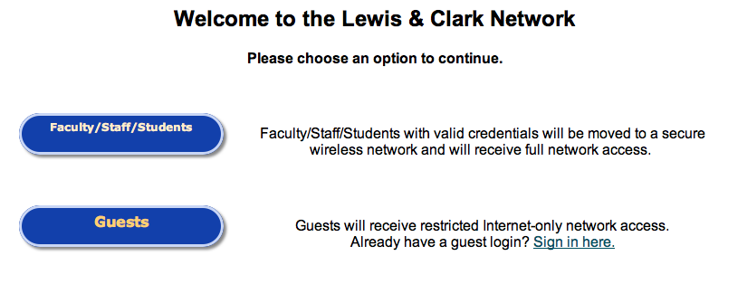
- Click Guests. You will be provided with the form below. Enter the requested information and click the Submit Information button.
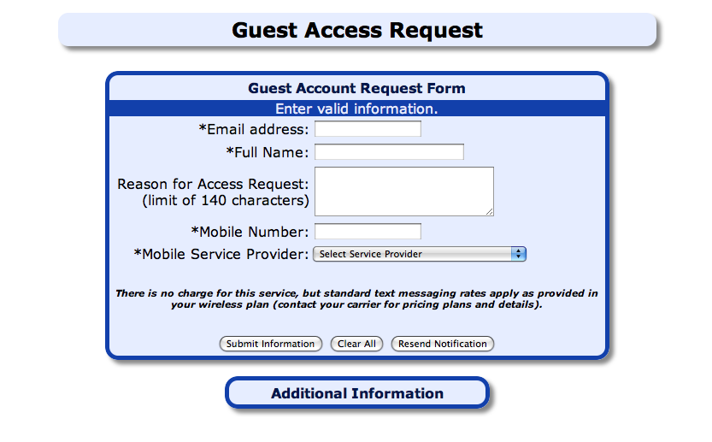
- You will receive the page below. Also, a username and password will be both texted to you and sent to you via email. Click where it says “click here to sign in”
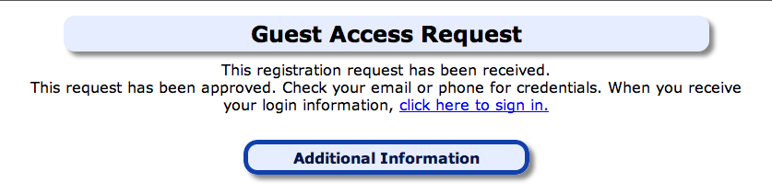
- You will be returned to this page. In the Guests section, click where it says Sign in Here.
- Enter the Username and Password that was sent to you and click Submit. You should be connected to the Internet.
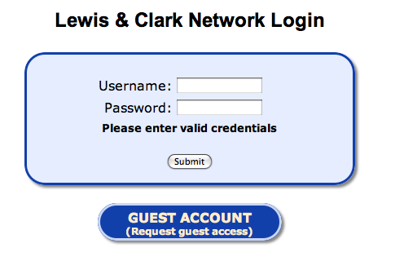
Note: If you do not have cellular service on campus, please come by the Information Technology office in Watzek Library to have a guest account created for you.
Guest access is valid for nine hours.

