FIELD REPORT: Field Report, 2/4/2014
Prepared by: | Larry Atchison
Project: | Manor Formal Garden Renovation
Weather: | Dry, partly cloudy and cold (28 at 8:00am)

Parties Present | Organization | Email Address
Larry Atchison | L&C Project Manager | atchison@lclark.edu

General Observation
Photos
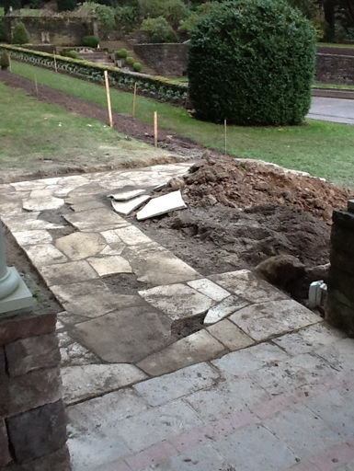  Stone entry to south Gazebo |  | 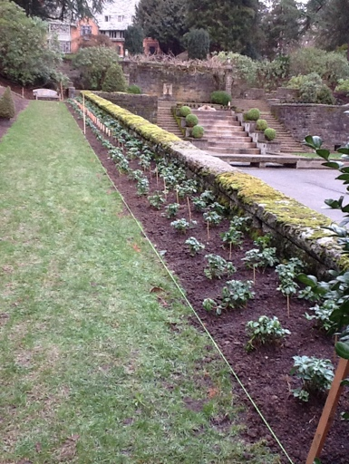  Plantings on south edge of Reflecting Pool
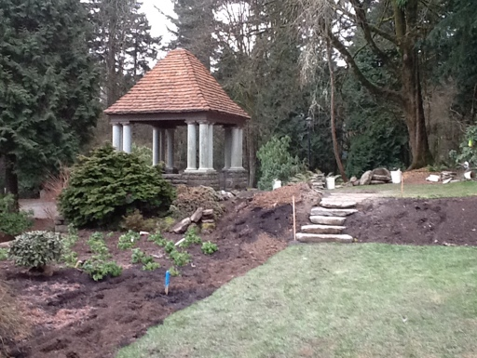  South Gazebo |  | 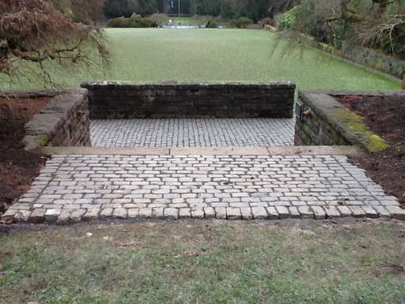  New cobblestone landing at the top of stairs
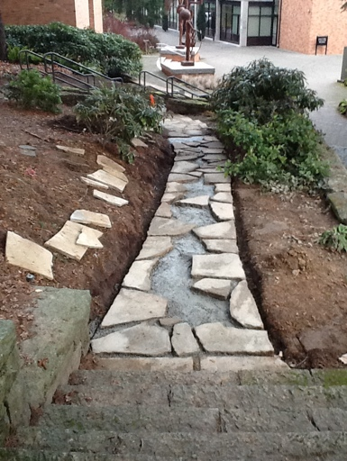  New stone walk to north Gazebo |  | 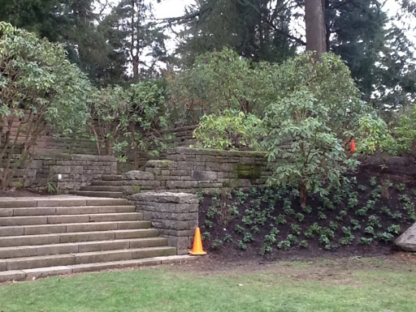  Pruning and new plantings at west end of the gardens
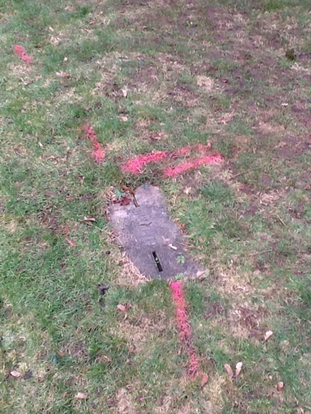
Underground utility locating completed.

