FIELD REPORT: Field Report, 3/18/2014
Prepared by: | Larry Atchison
Project: | Manor Formal Garden Renovation
Date/Time: | Tue, Mar 18 2014
Weather: | Sunny, mid 40's

Parties Present | Organization | Email Address
Larry Atchison |  | atchison@lclark.edu

General Observation
Photos
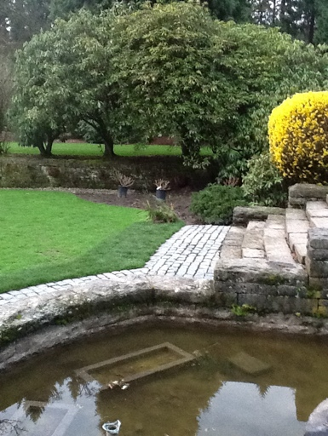  Plantings at lower fountain |  | 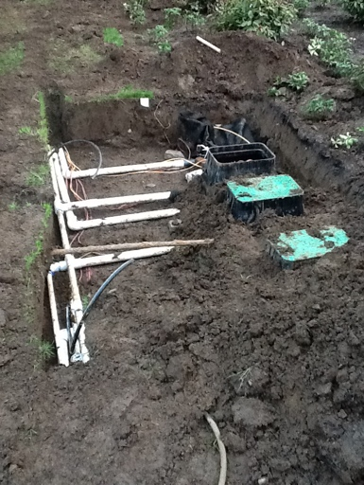  Irrigation installation in process
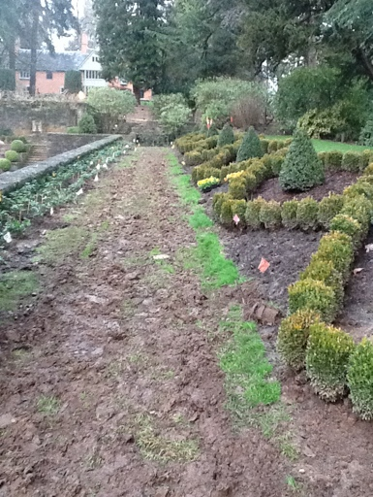  Irrigation and plantings along north side of Reflection Pool |  | 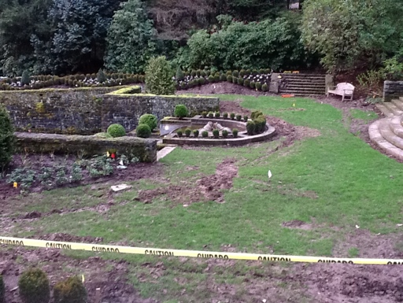  Flags for irrigation at the west end of Pool
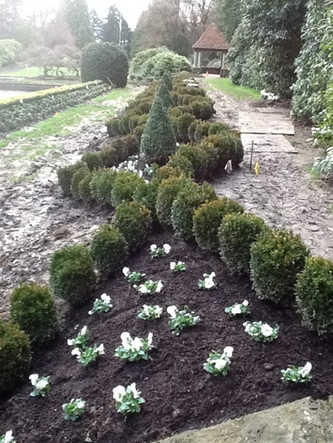
Flowers and boxwoods on south side of Pool

