FIELD REPORT: Field Report, 5/28/2014
Prepared by: | Larry Atchison
Project: | Health Center Entry Remodel

Parties Present | Organization | Email Address
Larry Atchison |  | atchison@lclark.edu

General Observation | - Casework installation scheduled for tomorrow
Photos
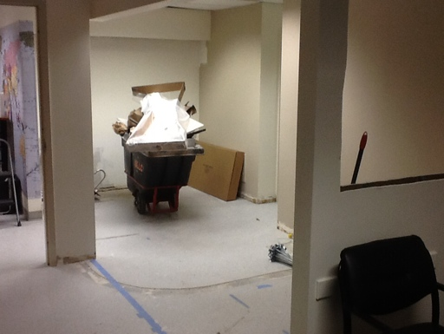  Drywall work complete. |  | 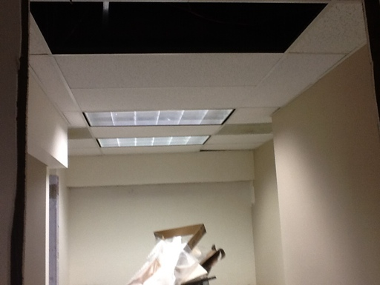  Ceiling grid work complete. Light to be relocated.
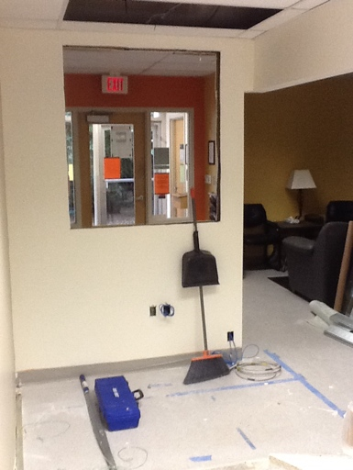
New window opening framed.

