FIELD REPORT: Field Report, 5/30/2014
Prepared by: | Larry Atchison
Project: | Akin Electrical System Replacement

Parties Present | Organization | Email Address
Larry Atchison |  | atchison@lclark.edu

General Observation | - Electrical utility company on site this morning to transfer power.  - Still tracking for 6/13 final completion.
Photos
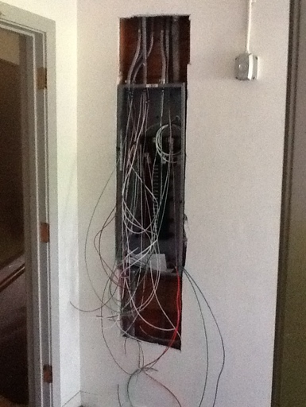  New electrical panels installed |  | 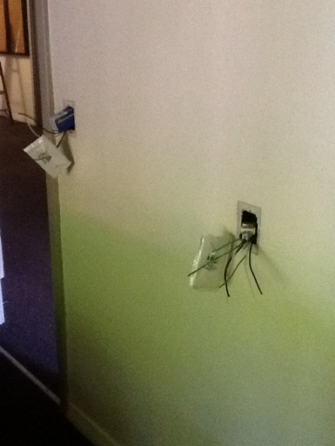  New conductors and receptacles
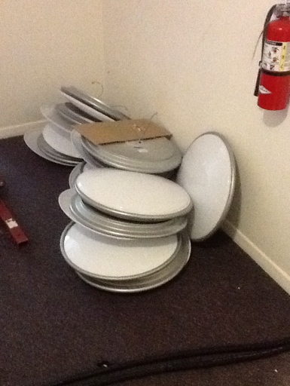
Existing room lighting to be relocated and used in hallways

