FIELD REPORT: Field Report, 6/10/2014
Prepared by: | Larry Atchison
Project: | Juniper Renovation

Parties Present | Organization | Email Address
Larry Atchison |  | atchison@lclark.edu

General Observation
Photos
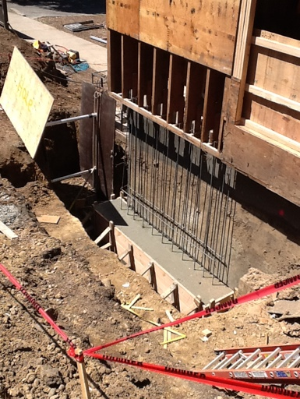  Footing for seismic upgrades |  | 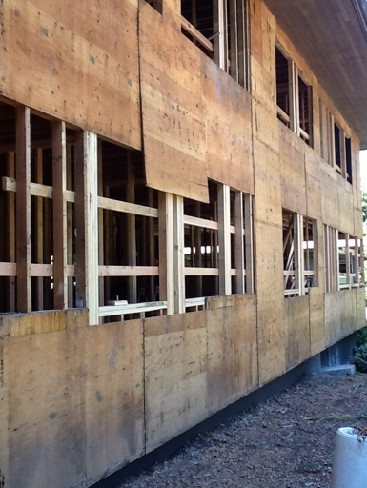  New window framing, east elevation
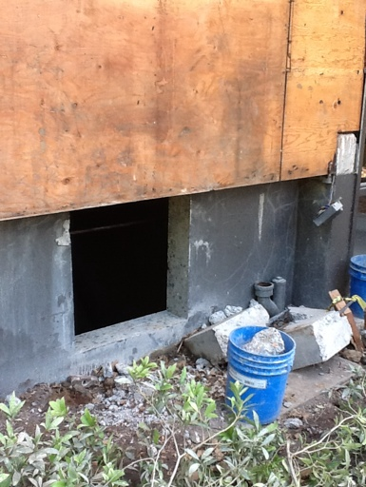  North foundation wall opening for new ventilation system |  | 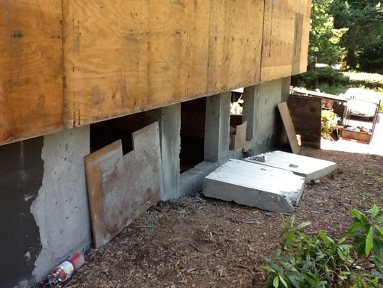  New basement windows, north elevation.
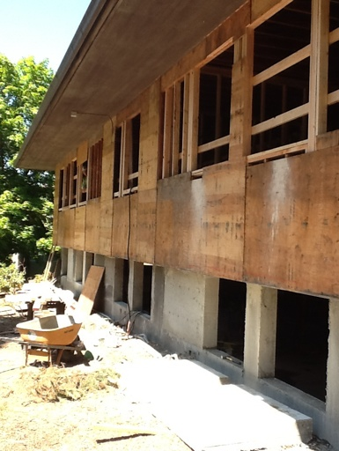  West wall |  | 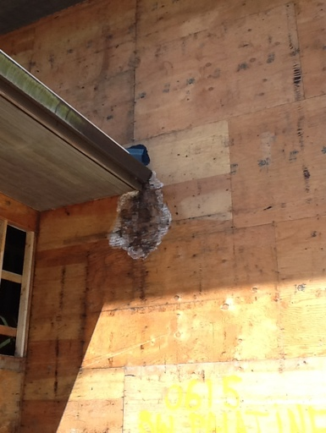  Only one area of rotted wall sheathing.
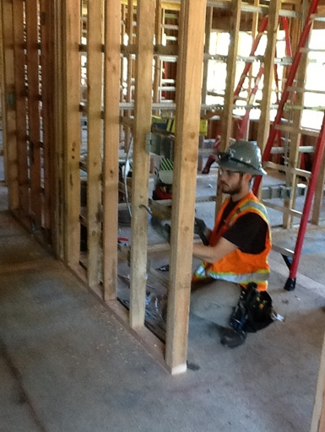  Electricians roughing in. |  | 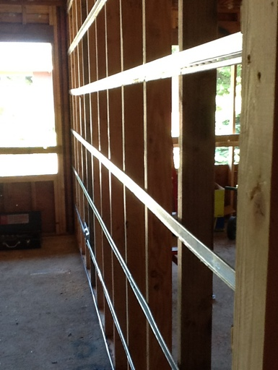  Channel on interior walls to help with acoustical separation between rooms
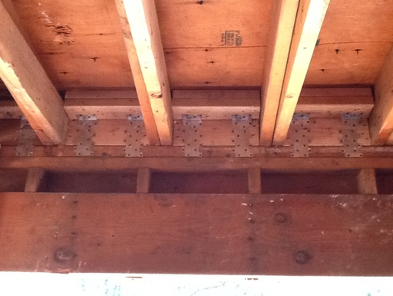  Clips from roof framing to walls for structural upgrades |  | 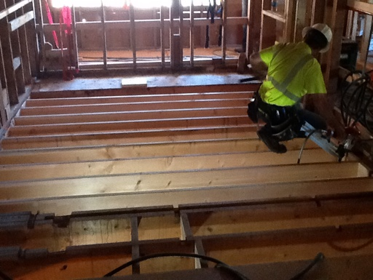  Replacing floor joists
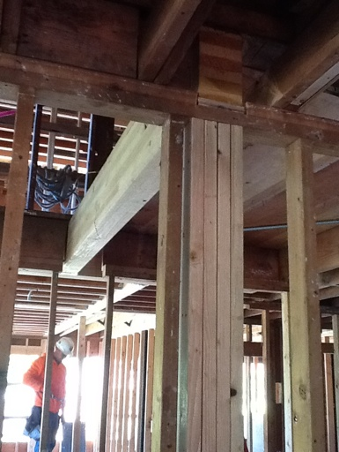  New beam at north entry stairwell |  | 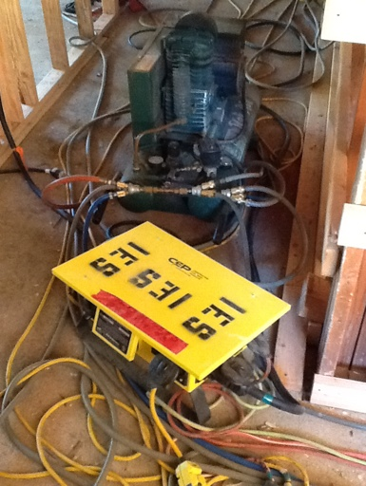  Cords & air hoses for 20 framers on site
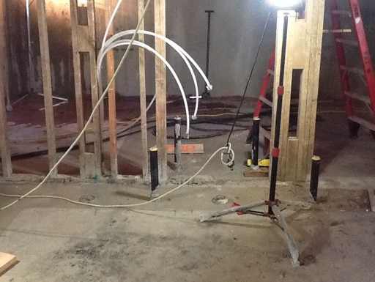
Plumbing rough in

