FIELD REPORT: Field Report, 6/17/2014
Prepared by: | Larry Atchison
Project: | Manor House Admission's Office Remodel

Parties Present | Organization | Email Address
Larry Atchison |  | atchison@lclark.edu

General Observation
Photos
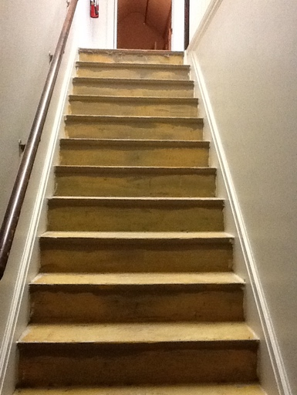  Carpet on stairs to attic offices being replaced. |  | 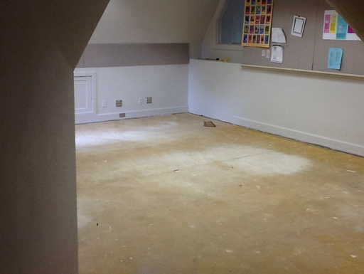  Attic offices being painted and new carpet installed.
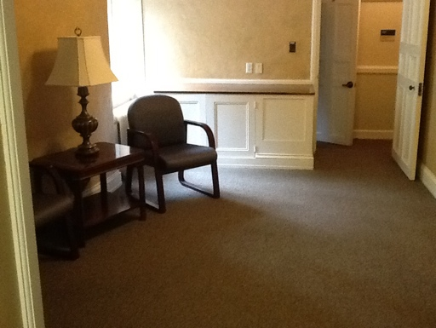
Lobby area to be renovated

