FIELD REPORT: Evans Report, 6/18/2013
Prepared by: | Larry Atchison
Weather: | Sunny and mid 70s

Parties Present | Organization | Email Address
Larry Atchison |  | atchison@lclark.edu

General Observation | - Exterior painting nearly complete  - Working on interior window seals  - New window screens on order
Photos
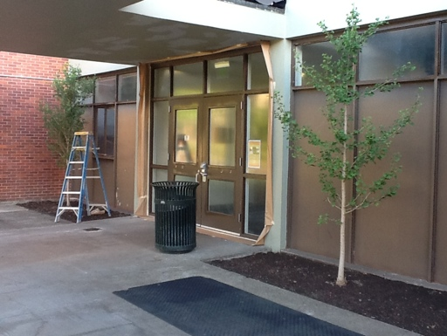  Front entry ready for paint |  | 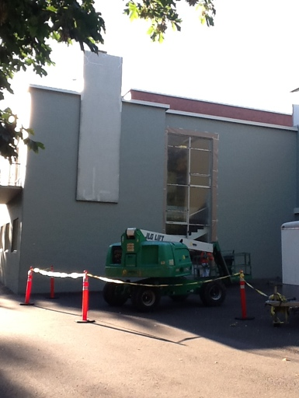  Ready for final paint
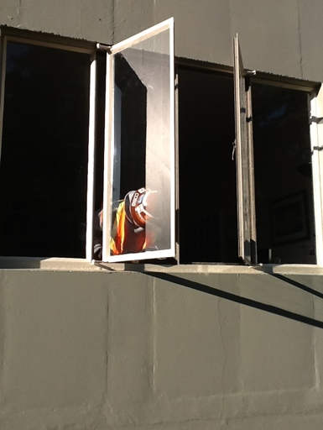
Work on the interior seals and latches of windows

