FIELD REPORT: Pamplin Access & Monitoring Report, 7/1/2013
Prepared by: | Larry Atchison

Parties Present | Organization | Email Address
Larry Atchison |  | atchison@lclark.edu

General Observation | - Control panels in place with wire pulled to it.  - Exterior doors ready for wire and hardware this week.  - Doors safe and accessible.
Photos
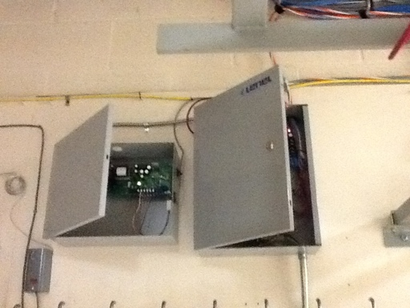  New Lenel controller panels mounted it IT room. |  | 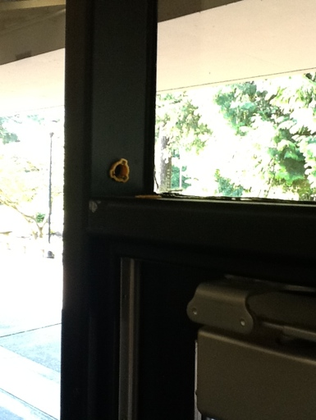  Pathway for new wiring to exterior doors is complete.

