FIELD REPORT: Sewer Report, Run B, 7/16/2013
Prepared by: | Larry Atchison

Parties Present | Organization | Email Address
Larry Atchison |  | atchison@lclark.edu

General Observation | - Getting started with this run this week.  - M&M Construction to have fencing in place this morning
Photos
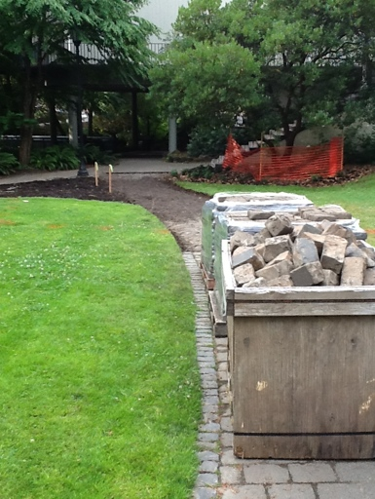  Pavers removed for new manhole |  | 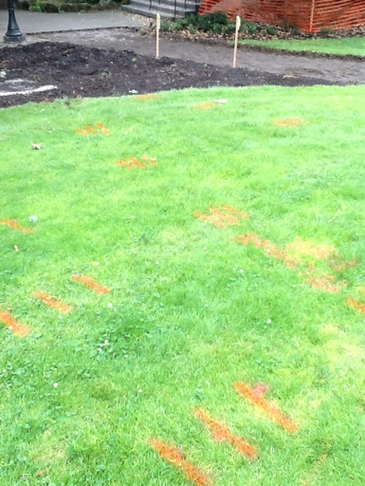  Survey stakes and utility locating paint
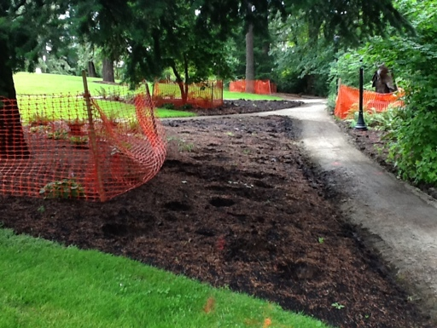  Tree protection in place and plants salvaged |  | 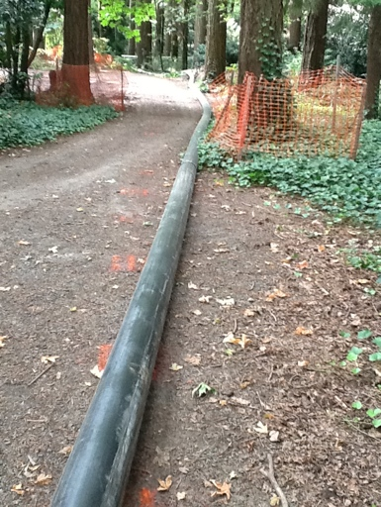  200' of 8" pipe welded and ready to be pulled through as existing pipe is burst

