FIELD REPORT: Campus Entry Field Report, 7/30/2013
Prepared by: | Larry Atchison

Parties Present | Organization | Email Address
Larry Atchison |  | atchison@lclark.edu

General Observation | - Gate 8 curing and will open July 31 for vehicles.  - Gate 2 will open for use on July 31.
Photos
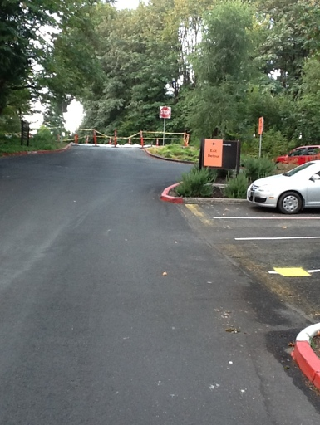  Gate 8 blocked and concrete curing. Exiting traffic routed out Gate 6 for this phase. |  | 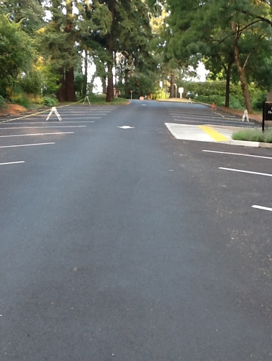  Hartzfeld lot closed to parking to accommodate two way traffic
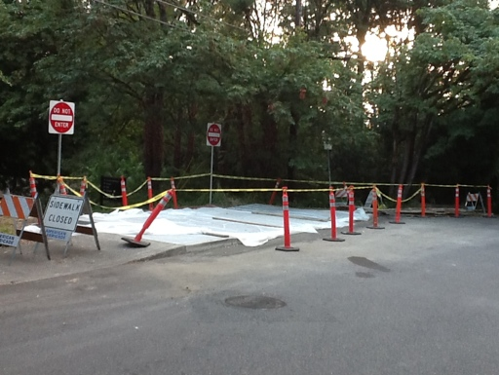  Gate 8 |  | 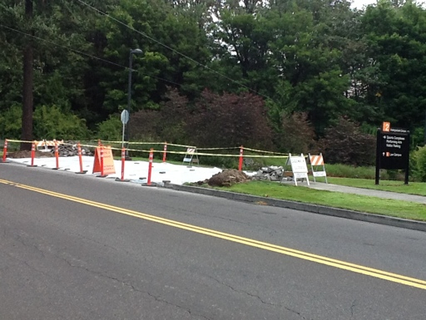  Gate 2 concrete curing.
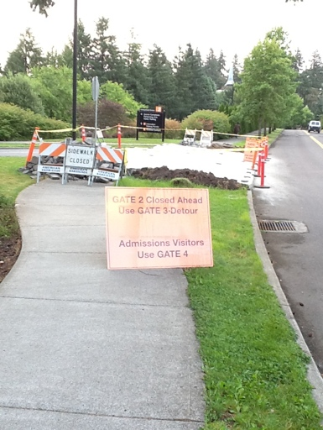
Gate 2 traffic routed to Gate 3 for this phase.

