FIELD REPORT: Field Report, 4/2/2014
Prepared by: | Larry Atchison
Project: | Manor Formal Garden Renovation
Date/Time: | Wed, Apr 2 2014
Weather: | Mid 40's and overcast

Parties Present | Organization | Email Address
Larry Atchison |  | atchison@lclark.edu

General Observation
Photos
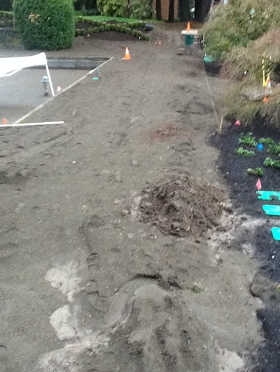  New sand base for sod |  | 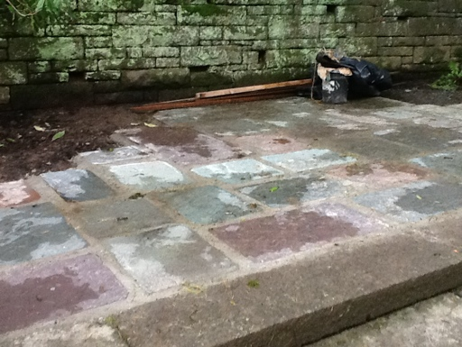  Uneven stones being fixed
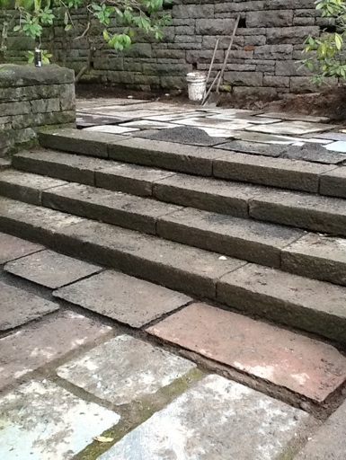
Stone repairs

