Climate Change Law- Powers (Fall 2016)
Science
- Greenhouse gases absorb infrared radiation emitted by the earth as it cools, and retransmit that energy back into the atmosphere
- Radiative forcing
  - Positive radiative forcing results in an increase in Earth’s energy budget and ultimately leads to warming. Because GHGs absorb infrared radiation and re-emit it back to the Earth’s surface, thus increasing the Earth’s energy balance, they have positive RF values.
  - Negative radiative forcing results in a decrease in the energy budget and ultimately leads to cooling. Aerosol particles reflect solar radiation, leading to a net cooling, and therefore have negative RF values.
- Global warming potential
  - Comparative measurement used to quantify warming effect of particular GHG
  - CO2 is the baseline (1)
  - Denoted by CO2eq
  - Methane (CH4) has GWP100 (global warming potential over 100 years) of ~28 but its atmospheric lifetime is around 12 years and has much greater impact over shorter time periods
- CO2
  - Emitters- energy, industry, building materials, land use
  - Sinks- plants, oceans
  - Reservoirs- trees, permafrost
- Methane (CH4)
  - Emitters- agriculture, coal and gas production
- Nitrous Oxide (NO2)
  - Emitters- agriculture (livestock, soil perturbation), vehicle exhaust, industry
- F-gases
  - Emitters- manufactured chemicals (air conditioning, electronics)
- Positive feedback loops
  - Rising heat melts permafrostproduces methanetraps more heatmelts more permafrost
- Negative feedback loops
  - Raised CO2 concentrationincreased plant growthlowered CO2 concentration
- GHG concentrations (especially CO2 with its lifespan of ~100 years) are additive
  - Conversely, reductions in GHG concentrations are also additive
Intergovernmental Panel on Climate Change
- Consensus based
- Figures and estimates may be conservative
- Working Groups
  - Working Group 1- aims at assessing the physical scientific basis of the climate system and climate change.
  - Working Group 2- assesses the vulnerability of socio-economic and natural systems to climate change, negative and positive consequences of climate change, and options for adapting to it. It also takes into consideration the inter-relationship between vulnerability, adaptation and sustainable development.
  - Working Group 3- assesses options for mitigating climate change through limiting or preventing greenhouse gas emissions and enhancing activities that remove them from the atmosphere. The main economic sectors are taken into account.
Mitigation
- Five considerations
  - Identify long-term impacts to avoid
  - Identify acceptable level of temperature rise
  - Identify level of GHG concentration associated with that temperature rise
  - Determine reductions in GHG emissions necessary to achieve desired concentrations
  - Formulate policies to affect this change
- Markets and externalities
  - Industries will externalize environmental costs absent regulation and customer preference
  - Market capitalism is blind to the environment
- Command and control regulation
  - Top down paradigm
    - Examples:
      - Emission limits
      - Mandated technological practices
      - Setting technological goals (e.g., fuel economy standards)
      - Product restrictions or bans
      - Purchasing requirements (e.g., renewable portfolio standards)
  - Common criticisms include:
    - Expensive
    - Inflexible
    - Administratively burdensome, costly
    - Discourage innovation- firms do the bare minimum to ensure compliance
  - Counterpoints
    - Environmental compliance costs have historically been low
    - Any regulatory regime will be administratively burdensome
    - Regulation is the mother of innovation
- Emissions trading
  - Regulators set sector or economy wide cap on emissions from covered sources
  - Emission credits/allowances allocated to sources
    - Market created to facilitate transfer, sale of credits
    - Allows sources to coordinate to determine most efficient use of emissions
  - Credits are allocated through lottery, auction, or historical emissions
  - At end of specified time, emissions are totaled and sources are required to submit credits to cover them
    - If emissions are greater than credits, sources may be fined or forced to purchase additional credits from other sources
    - If a source emits less than its credits, it may bank them or sell them
  - Credit allocation methodology
    - Auction
      - Purest embodiment of polluter pays principle
      - Reduces distributional distortions
    - Free allowance
      - Each entity given credits (usually based on historical emissions)
  - Benefits
    - Cost effective
    - Efficient allocation of emissions
    - Stimulates innovation
    - Hard limit on emissions
  - Criticisms
    - Subject to gaming by emission sources; credit allocation based on past emissions encourage an increase in emissions immediately prior to implementation
    - Administrative nightmare
    - Difficult to determine appropriate level of penalties that would actually spur innovation—those most likely to innovate are usually the ones with the lowest marginal costs
    - Over-allocation- other regulation/policy may make credit markets obsolete
    - Price floors/ceilings act as de facto taxes
- Carbon taxes
  - Taxes on activities that are carbon intensive or GHG intensive
  - Benefits
    - Ease of administration
    - Generates revenue
    - Avoids rent-seeking to a degree
    - Avoids misguided market signals associated with emissions trading systems
    - Predictability
  - Criticisms
    - Politically unfeasible
    - No fixed cap on emissions
    - Issues of international trade
- Sectoral mitigation
  - Energy
    - Reduced consumption
    - Increase efficiency
    - Fuel switching
  - Transportation
    - See, energy
  - Land use
    - Land conservation
    - Product switching
    - Reduce consumption
  - Buildings
  - Stabilization wedges
    - Implementation of contemporary, incremental mitigation efforts which produce exponentially large emission reductions in the future
    - Based on the lifespans of GHGs (particularly, CO2)
    - Examples
      - Fuel switching
      - Raising efficiency
      - Carbon capture
- Cost benefit analysis
  - Inherent problem is quantifying impossibly complex variables
    - Quantification always involves subjective biases
    - Future costs are essentially indeterminate
  - Another major problem is the uncertainty associated with determining probability of events to occur decades or centuries from now
  - Discount rates- wherein the life of your great-great-great grandchild is worth pennies on the dollar
International climate change regime
- Sources of international law, according to ICJ
  - Conventions
  - Custom
  - General principles
  - Judicial decisions and epistemological jurisprudence
- Treaties
  - Generally governed by Vienna Convention on Law of Treaties
  - Written agreement between states
  - Process, generally
    - Identification of needs and goals
    - Negotiation
      - Done through working groups, committees, experts, symposia
      - Draft texts are circulated among parties
      - Draft convention prepared by parties (or by chairperson if making modifications to existing agreement)
      - Conference of plenipotentiaries
      - Circulation of authentic text
    - Adoption and authentication
      - Adoption done by entire negotiating body, either by consensus or predetermined ratio of parties (Vienna Convention says 2/3 satisfies requirement)
      - Authentication is done by individual states, signifying their agreement to terms
      - Authentication proscribes acts which would defeat object and purpose of treaty
    - Ratification or accession
      - Ratification is the authoritative act (usually prescribed by domestic policies) by which states submit to terms of treaty
      - Accession occurs when a state, not previously a signatory or negotiating party, submits to terms of treaty
      - Ratification usually requires a deposit of an instrument of ratification
    - Entry into force
      - Date determined by text of treaty
      - Becomes binding on all ratifying parties
    - Renunciation and withdrawal
      - Renunciation or repudiation occurs after authentication but before ratification
      - Withdrawal, which occurs after ratification, is usually governed by terms of treaty
- Customary law
  - Practices of states, done under implicit belief that it is required by law
  - Must show that there is a rule of law being followed
  - State practice- states following a rule
  - Opinio juris- states act in accordance with a sense of obligation
  - Custom, once established, binds all states, regardless if they follow it or not
    - Examples: duty to warn of sea mines; 200 miles Exclusive Economic Zones of maritime control; Vienna Convention on the Law of Treaties
  - Treaties may create custom
  - States may claim exemption from custom through a demonstration of persistent objection
- General principles
  - Interpretive devices used to explicate vagaries in treaties
  - Softer than custom, generally
  - General principles in climate change
    - State sovereignty and duty to not abuse that right to the detriment of other’s sovereignty
    - Common but differentiated responsibilities
    - Equity and intergenerational equity
  - State sovereignty
    - Right to exclude, right to exploit resources, right to jurisdiction
    - Responsibility to care after domestic population
    - Limits
      - Territorial
      - Common concern of humankind- recognition of ubiquitous, man-made problems
      - Duty to cooperate to address certain issues
      - Obligation to not harm sovereign interests of other states
  - Common but differentiated responsibilities
    - Recognizes the inherent differences in the capacities of states to adapt to and mitigate climate change
    - Reflects historical, asymmetric contribution to climate change—that is, the United States’ cumulative emissions are far greater than any other state
    - Formulated under the premise that it is more equitable to have developed polluters, with their historically larger wealth, shoulder more of the costs associated with climate change
  - Equity and intergenerational equity
    - Looks at per capita emissions
    - Concerned with environmental justice
  - Precautionary principle
    - Principle 15- Rio Declaration
      - In order to protect the environment, the precautionary approach shall be widely applied by States according to their capabilities. Where there are threats of serious irreversible damage, lack of scientific certainty shall not be used as a reason for postponing cost-effective measures to prevent environmental degradation.
    - Reiterated by UNFCCC Art. 3.3
- Political history associated with climate change
  - “North-South” divide- between developed and less developed states
    - That is, between EU, Japan, US, Canada, Australia, Russia and the rest of the world
    - Developed nations desired unqualified emissions reductions
    - Less developed states did not want undue interference with economic development
  - G-77
    - Everybody but the west, basically
    - Not homogenous
  - EU v. US
    - EU historically desired more ambitious goals with a regional focus
    - US historically a bunch of schmucks (Reagan especially), wanted to inflict costs on everyone (China especially) through emissions trading
  - Divisions amongst developing states
    - AOSIS (small island states) have different goals than OPEC, China, India
    - Least developed African states have much more exigent needs
    - Brazil and saving the Amazon
  - Former Soviet states (economies in transition)
    - They have industrialized but foundering infrastructure
United Nations Framework Convention on Climate Change
- Preamble
  - Reiterates certain principles: common concern; state sovereignty and duty; sustainable development; common but differentiated responsibilities
- Article 1: Definitions
  - Emissions- release of GHGs or GHG precursors into atmosphere over specific area and time
  - GHG- all except those covered by Montreal Protocol
  - Reservoir- natural mode of GHG storage
  - Sink- process, activity or mechanism which removes GHG from atmosphere
  - Source- any process or activity which releases GHG into atmosphere
- Article 2: Objectives
  - “Stabilization of GHG concentrations in the atmosphere at a level that would prevent dangerous anthropogenic interference with the climate system within a time-frame sufficient to allow ecosystems to adapt naturally to climate change, to ensure that food production is not threatened and to enable economic development to proceed in a sustainable manner.”
- Article 4: Commitments
  - Divided according to category of party
    - Annex I- developed parties and former Soviet states (economies in transition)
    - Annex II- developed parties
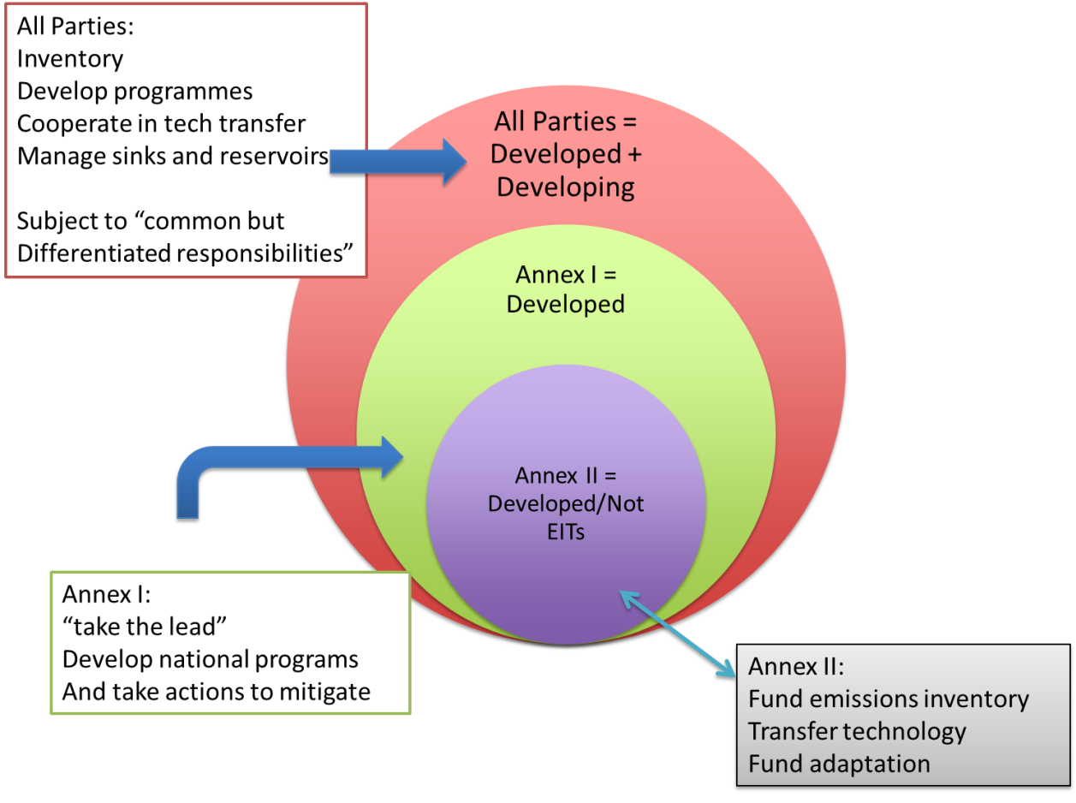
  - No binding commitments
  - Art. 4.1- covers all parties; recognizes common but differentiated responsibilities and disparate capacities
    - (a) Prepare, maintain inventories of sources and sinks
    - (b) Develop, monitor domestic measures to mitigate the effects of and adapt to climate change
    - (c) Promote and participate in technology transfer
    - (d) Promote sustainable management of sinks, reservoirs
    - (j) Communicate to COP relevant information to implementation
      - Art. 12.1 required disclosures- applicable to all parties
        - National inventories of sources and sinks
        - Steps taken to implement commitments
        - Any other relevant information
  - Art. 4.2- covers Annex I parties
    - (a) Enact policies and measures to limit anthropogenic emissions (e.g., sectoral mitigation) and protect, enhance sinks and reservoirs; parties may joint implement policies and measures (e.g., European Union)
    - (b) Explicitly calls for a return to 1990 emission levels at an undetermined date—not necessarily binding
    - (d) Review adequacy of current commitments
    - Must “take the lead” in innovating mitigation strategies
  - Art. 4.3- covers Annex II parties
    - Subsidize costs of reporting requirements of Art. 12 for all parties
    - Subsidize technology transfers to assist mitigation and adaptation measures
  - Art. 4.7- developing parties’ mitigation commitments are dependent upon Annex II parties fulfilling obligations
- Article 7- Structure
  - Delegates represent parties
  - Establish COPs
- Article 8- Secretariat
  - Arrange COPs (meeting every year); MOPs are meetings of parties to specific protocols, treaties
  - Compile, transmit reports
  - Subsidiary bodies- scientific and technology advisory committees
- Articles 15, 17- Amendments and protocols
  - Amendments- any party may propose; communicated at least six months before COP; requires ¾ parties present must approve
    - Later treaties may modify existing treaties
  - Protocols- only parties to UNFCCC may be part of protocol
- Entry into force, withdrawal
  - Entry- 90 days after deposit of 50th instrument of ratification
  - Withdrawal- (1) written notice; (2) effective one year after service of notice
    - Identical to Kyoto Protocol
- Important aspects
  - Categorical designation of parties
  - Funding mechanisms; obligations of Annex II parties to developing parties
  - Reporting requirements
  - Negotiating framework for future agreements
  - Definition of targeted pollutants
Kyoto Protocol (1997)
- Annex I (Annex B under Kyoto Protocol) parties committed to targets and timetables (QELROs)
  - Committed to 5.2 percent reduction below 1990 levels during reporting period (2008-2012)
- Definitions
  - Assigned amounts (AAs)- allowable emissions
  - Assigned Amount Units (AAUs)- measured in ton of CO2eq (tCO2eq)
  - Emission Reduction Units (ERUs)- credit for emission reductions; measured in tCO2eq
  - Certified Emission Reduction (CERs)- accumulated through clean development mechanism projects
  - Removal Units (RMUs)- emissions eliminated by sinks
- Adopted flexibility mechanisms
  - Joint fulfillment (EU bubble)- AAUs may be reallocated
  - Emissions trading- AAUs may be swapped
  - Joint implementation- ERUs generated and swapped between developed parties
  - Climate development mechanism- investment by more developed into less developed unit into a mitigation project; CERs used
- Art. 2: Policies and Measures
  - Applicable to Annex B (I) parties
  - Mandated mitigation efforts
- Art. 3: Targets and Timetables
  - Art. 3(1)- Annex B parties should reduce emissions at least five percent below 1990 levels during commitment period (2008-2012)
    - Gases include CO2, methane, nitrous oxide, HFCs, PFCs. SF6
  - Art. 3(2)- Annex B parties must show demonstrable progress toward commitments by 2005
  - Art. 3(7)- baselines differ between parties
    - Reductions must be made over commitment period
    - Therefore, party could exceed baseline in any given year, but the average of the five years should be lower than baseline
    - “Hot air”- former Soviet republics were allowed to emit full amount of 1990 emissions based on the premise that their emissions had dropped so precipitously after the collapse of the Union (but were expected to rise again)
      - Under emissions trading, developed countries (i.e., United States) sought to acquire these allowances cheaply and make no domestic attempt to curtail emissions
  - Art. 3(10)-(13)- Accounting
    - Allowed for AAU transfer, acquisition of ERUs and CERs
    - Trading of AAUs and ERUs is a zero sum endeavor; CERs are infinite and unregulated
    - Allowed for banking of AAUs
    - Parties are assigned a registry containing their assigned amount
- Flexibility mechanisms (see: slide 35 of Day 7 powerpoint)
  - Art. 4- Joint fulfillment (EU bubble)
    - Reallocate AAs between states participating in joint venture
    - Parties form subdivision of states to cooperatively meet aggregate emissions reductions
    - European Community formed- included EU states as of Kyoto Protocol
    - All parties within subdivision are liable for their collective goals; subdivision goal supplants Kyoto commitments
    - If group fails to meet aggregate obligations under Protocol, then Protocol requirements apply to individually to parties
  - Art. 17- Emissions trading
    - Market transfer of AAUs
    - Must be supplemented by domestic measures
    - Parties may allow private industry to participate (Decision 11); party establishes an account for private entities which they may use to trade internationally
    - Participation limited to Annex I parties and must be supplemented by domestic actions
  - Art. 6- Joint implementation
    - Project-based emissions trading
    - Must be additional and supplemental to domestic measures
    - Must demonstrate that project is completed
    - Must comply with Art. 5, 7 accounting prescriptions
    - ERUs are generated and traded in a zero sum arrangement
    - Track 1- Host party meets all eligibility requirements and verifies additionality
    - Track 2- Host party does not meet all eligibility requirements but receives verification from independent entity
    - Private firms may implement projects; must obtain approval of party states
    - Removal units may be earned through reforestation, afforestation projects
    - For projects started in 2000, credits start being earned in 2008
  - Art. 12- Clean development mechanism
    - Annex I parties may commission emission-reduction projects in non-Annex I parties
    - Non-Annex I parties benefit from projects through sustainable development and technology transfers
    - CDM limited to emission reduction projects, not carbon removal (excludes reforestation, afforestation projects)
    - Non-Annex I parties may initiate CDM projects unilaterally and then sell CERs
    - Projects started in 2000 started earning credits immediately
    - Participation in CDM projects must be voluntary, have real and measurable and long-term benefits, and must be additional to the status quo
    - Executive board established to monitor, implement program
    - Implementation
      - Applicant develops Project Design Document (PDD) and present it to Designated National Authority (DNA) who then issues approval
      - Designated Operational Entity (DOE) is then certified to:
        - Review methodology
        - Validate proposals
        - Verify emissions reductions
        - Solicit comments from stakeholders
        - Monitors compliance
      - DOE is typically third party contractor
      - DOE issues report to Executive Board and CERs are granted
    - Conflicts of interest may arise with DOE
    - Appeals process is muddled
    - Over-allocation of credits may result from:
      - Technological limitations associated with quantifying emissions
      - Outside variables affecting emissions (e.g., market forces reducing demand)
      - Using general methodologies which ignore local exigencies
    - Leakage- measurable emissions increase caused by project but outside boundary of project
      - Spillover is the positive equivalent of leakage
      - Parties are required to assess, subtract leakage from reductions totals
    - Problems with CDM
      - Limited types of eligible projects- deforestation reduction ineligible; must reduce emissions which means that renewable energy development that does not displace thermal generation is ineligible
      - HFC generation and gaming- destroying gases produced in manufacturing of refrigerants used to generate credits
      - Inequitable distribution- China dominates market
  - Supplementarity
    - Parties were conflicted as to what degree flexibility mechanisms should account for emissions reductions as opposed to domestic measures
    - Some wanted a minimum of fifty percent reductions from domestic measures; others wanted no requirement (i.e., US)
    - Ultimately, parties agreed that domestic action shall constitute a significant element of the effort made by each Annex I party
    - Issues of enforcement persist
  - Additionality
    - Briefly, the concept states that projects should result in emissions reductions that would not occur but for the project
    - Three problems: establishing baselines; proving additionality; dealing with leakage
      - Technological leakage- dirtier methods displaced by projects transfer to other markets, sectors; includes unforeseen consequences
      - Market leakage- “rebound effect”; as technologies get more energy efficient, cheaper their use increases, thereby negating any emissions reductions
    - Baselines- ordered by preference
      - Approach A- based on existing actual or historical emissions; used where existing activities are most likely to continue
      - Approach B- using economic rationality, calculate emissions from the most economically attractive alternative to project; used for projects involving activities which do not exist already (e.g., building additional energy infrastructure)
      - Approach C- average of emissions of “top twenty percent” of similar projects or activities over last five years; considers social, economic, environmental and technological circumstances
    - Proving additionality- determines whether project would have been created without CDM assistance
      - Identify CDM project and alternatives
      - Determine whether project was viable absent CDM assistance (investment and barrier analysis); if yes, then it is additional
      - Common practice analysis- is CDM project like other projects in the area
Kyoto to Paris
- Bali Action Plan (2007)- committed to establishing post-Kyoto agreement by 2009
  - Kyoto Protocol entered into force by 2005
  - Sovereignty-first approach with respect to major emitters
  - G8 desired participation of all major emitters including India, China, Brazil (through nationally appropriate mitigation actions NAMAs)
  - Stated that parties needed to develop “shared vision for long-term cooperative action”; requiring consensus
  - Agreement
    - Developed countries- QELROs (maintaining KP AAUs); measurable reportable verifiable commitments
    - Developing- develop NAMAs
- Copenhagen Accord (2009)
  - Developing nations desired that Annex I parties continue to take lead, desired that nationally appropriate mitigation actions (NAMAs) be non-binding
  - US was intransigent in stance that China, India be included in emissions reductions
  - Agreement
    - Stabilize GHG concentrations at level that will prevent dangerous anthropogenic interference with climate system (<2’C temperature rise)
    - Emissions should peak as soon as possible
    - Increased adaptation efforts in least developed, island nations
    - Annex I parties to set economy wide targets by 2020; non-Annex I parties to submit NAMAs (both at later dates)
    - Increase funding to 100$b/year by 2020
    - Established bottom up, party specific goal structure used by Paris Agreement; however, commitments were toothless, largely meaningless
    - Reassess accord by 2015
- Varying approaches
  - Intensity targets- reduce amount of carbon per unit of GDP
    - May be more pragmatic than emissions reductions (which may fluctuate based on extrinsic economic factors)
  - Policies and measures (PAMs)
    - Headroom targets
    - Policy focused instead of purely results-focused emissions reductions
- After Copenhagen
  - Meetings in Cancun, Durban (RSA), Doha (Qatar), Warsaw, Lima, Paris
- Kyoto Protocol II (2013-2020)
  - Basically consists only of Europe, non-Annex I, Australia
  - US, Canada, Japan, Russia, New Zealand have all essentially extricated themselves from agreement
  - Targets and timetables instituted by Copenhagen Accord, adjusted to uniform baseline
  - Flexibility mechanisms
    - Non-KP II parties can still participate in CDM, joint implementation but do not receive credits any longer
  - Credits have basically been banked, are in limbo
- Pre-Paris concerns
  - What are adequate reporting requirements (measurement, reporting, verification—MRV)
    - Some developing countries oppose being subject to requirements under premise of sovereignty
  - Adaptation- national adaptation programs of actions (NAPAs), tactics; national adaptation plans (NAPs), implementation plans
  - Green Climate Fund- independent, more representative than World Bank
- Lima Accord (2012)
  - Parties agreed to submit Intended Nationally Determined Contributions (INDCs)
    - Domestic commitmentsmultilateral agreement
  - INDCs reinforced common but differentiated responsibilities, disparate capabilities
    - Became NDCs after Paris Agreement came into force
Paris Agreement (2015)
- Art. 2- Goals
  - “(a) Holding the increase in the global average temperature to well below 2°C above pre-industrial levels and to pursue efforts to limit the temperature increase to 1.5 °C above pre-industrial levels, recognizing that this would significantly reduce the risks and impacts of climate change;
  - (b) Increasing the ability to adapt to the adverse impacts of climate change and foster climate resilience and low greenhouse gas emissions development, in a manner that does not threaten food production;
  - (c) Making finance flows consistent with a pathway towards low greenhouse gas emissions and climate-resilient development.”
  - Sustainability- three pillars: environment, equity, economics
- Art. 4- Mitigation
  - Art. 4.1- peak emissions and obtain carbon neutral global economy
  - Art. 4.2, 3- subsequent Nationally Determined Contributions (NDCs) must be progressive to prior ones and must reflect the highest ambition under common but differentiated responsibilities
  - Art. 4.4- developed parties must establish economy wide caps; developing parties eventually work toward this
  - Art. 4.5- developed parties offer support to developing parties to that end
  - Art. 4.7- ancillary benefits to adaptation measures may count towards mitigation goals
  - Art. 4.9, 12- NDCs to be submitted and published every five years
  - Art. 4.13- avoid double counting contributions
  - Art. 4.16-18- formally blesses EU Bubble (now with 100% less UK, maybe)
  - Art. 4.19- parties should formulate low emission, long term development plans
- Art. 6- Cooperation
  - Art. 6.2- avoid double counting internationally transferred mitigation outcomes (ITMOs)
    - Different from CDM in that credits can no longer be generated a la CERs; trading is purely a zero sum game
    - CDM is dead
    - Will be formally resolved in Marrakech CoP/MoP
  - Art. 6.3- participation in ITMOs should be voluntary
  - Art. 6.4- sets up mechanism, administrative body
    - (a) To promote the mitigation of greenhouse gas emissions while fostering sustainable development;
    - (b) To incentivize and facilitate participation in the mitigation of greenhouse gas emissions by public and private entities authorized by a Party;
    - (c) To contribute to the reduction of emission levels in the host Party, which will benefit from mitigation activities resulting in emission reductions that can also be used by another Party to fulfil its nationally determined contribution; and
    - (d) To deliver an overall mitigation in global emissions.
  - Art. 6.5- avoid double counting
  - Art. 6.6- proceeds should cover administrative costs and help pay for adaptation
  - Art. 6.8- encourages non-market approaches
- Art. 7- Adaptation
  - Art. 7.1- “Parties hereby establish the global goal on adaptation of enhancing adaptive capacity, strengthening resilience and reducing vulnerability to climate change, with a view to contributing to sustainable development and ensuring an adequate adaptation response in the context of the temperature goal referred to in Article 2.”
  - Art. 7.4- mitigation can lead to less of a need for adaptation
  - Art. 7.5- adaptation measures should be socially equitable and based on best available science
  - Art. 7.9- each party is ultimately responsible for adaptation and planning
- Art. 9- Funding
  - Art. 9.1- developed parties should help developing
  - Art. 9.3- funding should come from diverse sources
  - Art. 9.4- balance funding between mitigation and adaptation
- Art. 10- Technology transfer
  - Art. 10.1- global goal is to enhance adaptive capacity, resilience, and sustainable development
  - Art. 10.4- more mitigation reduces need for more adaptation
  - Art. 10.5- adaptation should be country-driven, gender-responsive, participatory, transparent, etc. (don’t use adaptation as excuse for bad social policy)
  - Art. 10.9- each party is responsible for adaptation and planning
- Art. 11- Capacity building
  - Country driven and help developing parties
- Art. 14- Global stocktake
  - Art. 14.1- parties periodically assess implementation to determine progress
  - Art. 14.2- first assessment to take place 2023 and every five years thereafter
  - Art. 14.3- will inform parties with respect to NDCs
- Art. 20- Ratification
  - Deadline is April 21, 2017 for ratification, acceptance or approval
  - “Acceptance or approval” allows US to ratify without going through Senate
- Art. 21- Entry into force
  - After 55 parties accounting for 55 percent of GHG emissions
  - ALMOST THERE (update: WE’RE THERE)
US climate regime
- Clean Air Act
  - National ambient air quality standards (NAAQS)
    - Nationally applicable standards covering criteria pollutants (may cause or contribute to endangerment of public health or welfare)
      - Criteria pollutants: carbon monoxide; sulfur dioxide; nitrogen oxide; particulate material; lead; ozone
      - Efforts to list GHG as criteria pollutants are hampered by the fact that they are “well-mixed”
    - Primary standards cover public health with safety margin
    - Secondary standards cover public welfare (includes climate)
    - State implementation plans (SIPs) enforce NAAQS
    - Usually expressed in parts per million over period of time
    - Arguably, if something is not a criteria pollutant and not covered under NESHAPS, the CAA does not cover it
  - Mobile source standards (§ 202)
    - Standards apply to pollutants that, in EPA’s judgment (through endangerment finding), cause or contribute to endangerment of public health or welfare
      - Endangerment plus cause or contribute (§ 202(a))- “[t]he Administrator shall by regulation prescribe … standards applicable to the emission of any air pollutant from any class or classes of new motor vehicles or new motor vehicle engines, which in his judgment cause, or contribute to, air pollution which may reasonably be anticipated to endanger public health or welfare.”
      - In December 2009 (in response to MA v. EPA), EPA made endangerment finding related to six GHGs; promulgated Tailpipe Rule in response
      - Because of endangerment finding, EPA has non-discretionary, statutory duty to also promulgate PSD GHG standards (absent policy exigencies); EPA issued timing rule to delay such application
    - Uses technology-based controls
      - Costs of compliance are considered
      - Marginal gains can be made in materials, combustion efficiency, design
    - Standards are set prospectively
    - EPA may establish preemptive standards
      - Used in conjunction with NHTSA corporate average fuel economy (CAFE) standards
      - Limits emissions (measured in grams per mile) implemented through fuel economy standards (measured in miles per gallon)
      - California, on account of its more stringent standards and the fact that it established standards prior to CAA, is exempt (states may opt into California’s standards)
    - Massachusetts v. EPA
      - States and civil society groups petitioned EPA for rulemaking to cover CO2 under § 202 (vehicle emissions standards)
      - EPA refused to make endangerment finding; contended that piecemeal approach to climate change would be unwise, CAA amendments in 1990 did not address regulating CO2, CO2 emissions covered under other regulatory regimes (fuel economy standards), CO2 is not pollutant
      - Court held against EPA; must make endangerment/non-endangerment finding, can avoid taking further action if GHG do not contribute to climate change or if EPA can provide reasonable explanation to not exercise discretion
        - GHG clearly pollutant
        - Overlapping regulatory regimes are exclusive enough
    - Coalition for Responsible Regulation v. EPA (DC Ckt 2012)
      - Challenge to Tailpipe Rule (setting GHG standards for motor vehicles)
      - Because they feared regulation of stationary sources, petitioners contended that:
        - Science in record was inadequate
        - EPA failed to consider policy implications
        - Regulation of American GHGs would not mitigate climate change
        - Two GHGs included in regulation (sulfur hexafluoride (SF6) and perfluorocarbons (PFCs)) did not emanate from vehicles
      - Court held that:
        - Statutory language, MA v. EPA foreclosed consideration of policy implications
        - Agencies are afforded great deal of deference in their judgment of scientific findings
        - EPA need not quantify degree of climate change mitigation caused by rule
        - No petitioner had injury (and, therefore, standing) from inclusion of two GHGs
      - DC Ckt has likely concluded (for future litigation purposes) that anthropogenic GHG emissions cause climate change
    - California waiver program (§ 209, 177)
      - Must be shown that state standards are at least as protective of public health and welfare as federal standards; California enjoys a positive presumption of this
      - Even if protections are adequate, EPA may deny waiver if (§ 209(b)(1)):
        - Protectiveness determination by state was arbitrary and capricious
        - State does not have “compelling and extraordinary conditions” necessitating waiver (i.e., local topographical, meteorological considerations)
        - State standards and enforcement are not consistent with § 202(a) (i.e., must be technology-based standards)
      - § 177- states may opt into CA standards if they have their own nonattainment plans
      - EPA gives deference to CA’s findings; must grant waiver unless it can make § 209(b)(1) determination (difficult to challenge grant of waiver)
  - New source performance standards (NSPS)
    - Nationally applicable standards covering new and modified sources
    - Divided among categories of sources
    - Technology based standards (best adequately demonstrated technology (BADT))
    - Clean Power Plan- standards for existing sources for certain pollutants
  - Prevention of significant deterioration (PSD)
    - Applies to major sources in attainment areas (emit or potential to emit 100 tons per year (tpy) of any single pollutant for certain (28) categories of industry, 250 tpy for all others)
    - Requirements: pre-construction review; permit; compliance with emission limitations; protect air quality
    - Technology based standard- best available control technology (BACT)
      - Based on the maximum degree of reduction, taking into account energy, environment, economics
      - Established on ad hoc basis- five step approach applied
        - Identify all available technologies
        - Eliminate technically infeasible options
        - Rank remaining options
        - Evaluate options according to criteria (1.4.3.1)
        - Select technology
      - Cannot redefine a source (converting one type of thermal generation to another)
    - Triggering BACT
      - Pollutant emissions must exceed a significant emissions rate (SER) (usually, 40 tons per year); that is, a new OR modified source must result in an increase in emissions exceeding baseline (baseline for new sources is zero)
    - Regulated pollutant- any pollutant subject to regulation under any provision in the CAA
      - EPA interpreted this to mean that the pollutant be subject to emission controls
    - Existing sources- must (1) undergo physical or operational change AND (2) significant emissions increase of a regulated pollutant AND (3) be a major source
    - Triggering PSD
      - Must be major source
      - Must exceed SER (for new sources) or result in significant emissions increase (for modified sources) (only “significant” pollutants will be subject to BACT)
    - Tailoring Rule- where GHG emissions trigger BACT
      - New sources
        - “Anyway” sources- traditional major source which also emits some mass (>0 tpy) of GHG with GWP of at least 75k tpy CO2e
        - Other sources- 100/250 tpy of GHG with GWP of at least 100k tpy CO2e; invalidated by Utility Air Regulatory Group v. EPA
      - Existing sources
        - Identical to “anyway” sources that undergo modification
      - Sources emitting CO2eq of 50k tpy would not be subject to regulation for six years
    - UARG v. EPA
      - CAA did not mandate regulation of GHG
      - GHG emissions alone cannot trigger PSD as it ignores statutory language
      - Regulating GHG emissions from “anyway” sources is permissible so long as emissions are not de minimis
  - Non-attainment new source review (NNSR)
- Clean Power Plan
  - Formulated under § 111(d) of CAA (NSPS program- technology-based standards for categories of industry)
    - § 111(d) covers existing source performance standards for pollutants emitted by categories of industry covered by NSPS
    - EPA made endangerment finding regarding emissions from thermal generating facilities
  - Covers performance standards for existing sources- 1305 lbs CO2/MWh for fossil fuel-fired electric steam generating units (coal); 771 lbs CO2/MWh for stationary combustion units (natural gas)
  - Compliance options
    - Emission performance rates
      - Established by EPA; enumerated by 2.2
      - States may choose to implement standards
    - Rate-based or mass-based standards
      - State specific; based upon total number and type of plants (represented as a weighted average)
      - All plants within state must meet weighted average rate
      - Some states may choose to allow emissions trading mechanisms between plants (rate-based states may only trade intrastate)
    - State measures with standards as a backstop
      - State specific; mass-based limits- caps total annual emissions at certain mass
      - Allows states to incorporate SIPs, RPSs (i.e., state measures) into emissions
      - May use statewide/regional market-based approaches (e.g., cap and trade)
      - Only mass-based states may enter into regional emissions trading markets
  - Setting rates- best system of emissions reductions (BSER)
    - Building block 1- reduce carbon intensity of power generation through improving thermodynamic efficiency; done at unit level
      - Ultimately only leads to 2-4% reduction in emissions
    - Building block 2- substitute generation from coal plants to natural gas units
    - Building block 3- substitute generation from coal to zero-emitting renewable sources
  - Statutory authority (or lack thereof)
    - House and Senate versions of § 111(d) were passed and at odds as to whether EPA can regulate CO2 from existing power plants
      - EPA argued in front of DC Circuit that they were entitled to deference because of the ambiguity imposed by this conflict
  - Determining standards- using BSER
    - § 111(d)- states must submit plans to EPA establishing “standards of performance”
    - Standards of performance- “reflects the degree of emission limitation achievable through the application of the best system of emission reduction which (taking into account the cost of achieving such reduction and any non-air-quality health and environmental impact and energy requirements) the [EPA] determines has been adequately demonstrated.”
    - “Best” standards
      - Based on cost; source specific and applicable sector-wide
      - Can consider energy variables (i.e., energy associated with carbon capture/sequestration)
- Corporate Average Fuel Economy (CAFE) Standards
  - Formulated in response to Arab oil embargo by Energy Policy and Conservation Act (1975)
  - Fleet wide average fuel economy standards
  - Standard is “maximum feasible average fuel economy” in each model year
    - Consideration factors- (1) technological feasibility; (2) economic practicability; (3) effect of other federal standards on fuel economy; (4) need of nation to conserve energy
    - “Maximization occurs when the incremental change in industry-wide compliance costs from adjusting [standards] further would be exactly offset by the resulting incremental changes in benefits.” (CBD v. NHTSA)
    - For passenger vehicles, 18.5 mpg minimum for model year 1978; presumptive minimum of 27.5 mpg by model year 1985 (not mandatory minimum, still bound to “maximum feasible” standard)
  - Fleetwide standards
    - Fleet- category of vehicles; e.g., passenger vehicles; non-passenger vehicles; work trucks
      - Passenger vehicles- designed primarily for transport; excludes vehicles that are capable of off-road transport and possess another feature (other than all-wheel drive) for that end; excludes all-wheel drive vehicles; excludes vehicles heavier than 6K lbs.
      - Work trucks- not designed for personal transport and weigh between 8.5K and 10K lbs.
      - All other vehicles are non-passenger
    - Passenger vehicle standards do not apply to non-passenger vehicles
    - Within a specific fleet, manufacturers must ensure that the average fuel economy of all vehicles meets certain standards
  - Initial approach
    - Vehicle classifications led to “SUV loophole”
      - Non-passenger vehicles became intensely popular after gas prices fell and people presumed that they were safer
      - Therefore, overall fuel economy fell
    - Center for Auto Safety v. NHTSA (1986)
      - Whether NHTSA improperly gave too much weight to consumer demand as a factor when promulgating CAFE standards
        - No; fits within technological feasibility, economic practicability factors
      - However, “it would clearly be impermissible for NHTSA to rely on consumer demand to such an extent that it ignored the overarching goal of fuel conservation.”
    - In effect, fleetwide standards and vehicle classification ensured that there were no minimum standards
  - Reform
    - Congress imposed moratorium, through funding revocation, on revision of standards until further studies could be conducted by National Academy of Science
    - NAS found that rebound effect (people driving more because of increased fuel economy) would be de minimis, should consider using attribute-based—not fleetwide—standards, should consider long term effects in cost/benefit analysis
    - NAS recommendations
      - Physical attributes of vehicles dictate standards
      - Footprint approach- measured using wheelbase
    - Reformed CAFE
      - Fleetwide standards based upon the proportion of vehicles of certain footprints- that is, if manufacturer produced solely large footprint vehicles, its standards would be more relaxed
        - Proportions are based on projections
      - Attribute based standards
      - Did not include backstop of effective minimum standards
      - Did not include cost assessment of GHG emissions
      - Did not change definitions to close SUV loophole
    - Center for Biological Diversity v. NHTSA (2008)
      - Litigating reformed CAFE
      - Court found:
        - Energy Policy and Conservation Act did not mandate a backstop, but NHTSA should have included one nonetheless (decision not to have one was arbitrary and capricious)
        - NHTSA should have quantified costs/benefits associated with GHG emissions
        - Decision not to change vehicle definitions was arbitrary and capricious- many non-passenger vehicles are used solely in personal transportation
  - Energy Independence and Security Act (2007)
    - Mandated combined average fuel economy for all vehicles not work trucks at 35 mpg by model year 2020
    - Beyond 2020, maximum feasible average reinstated
    - Standards set according to vehicle attributes (reformed CAFE)
    - Minimum standards for domestically manufactured passenger vehicles
      - 27.5 mpg or 92 percent of fleetwide average of all manufacturers
    - Projection- by 2025, combined fleet economy may be 54.5 mpg
- Renewable Fuel Standard (RFS)
  - Corn ethanol makes up 95% of biofuels manufactured in US; biodiesel is predominant in Europe
    - Advanced (second generation) biofuels include sugarcane ethanol, algae, cellulosic based fuels, biodiesel
    - Compressed natural gas is used in some municipal fleets
  - Corn as king
    - Result of agriculture subsidies and tax incentives (most originating from New Deal era policies updated in the 1970s)
    - Crop surpluses led to new uses, ethanol subsidies at beginning of twentieth century
  - Energy Policy Act (2005)- created first renewable fuel standard (RFS1)
    - Four billion gallons blended by 2006, 7.5 billion by 2012
    - Did not include carve outs or mandates for specific types of fuels
    - RFS program is an amendment to mobile source program of CAA
  - Implementation
    - Fixed volumetric standards set by statute
    - EPA calculates estimated fuel consumed by “obligated parties” (oil blenders, refiners, importers); then calculates percentage RFS for sector as a whole
    - EPA takes sector-wide percentage and applies it as volume-based (in gallons) mandates to individual firms (renewable volumetric obligation- RVO)
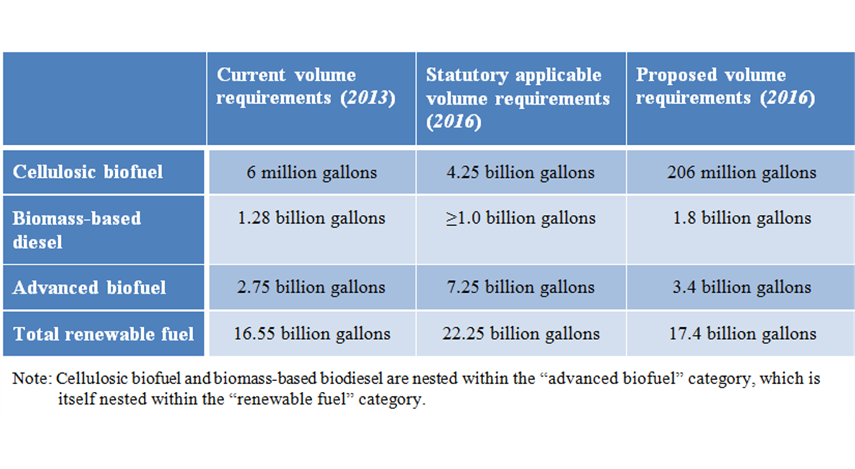
  - Problems with implementation
    - Obligated parties
    - Blend wall
      - Engines built before 2001 corrode when using fuel with more than 10% of ethanol
      - Retail suppliers refuse to market fuels with higher blends
      - Fuel consumption overall has declined
    - Waiver program- EPA may waive RFS if “implementation would severely harm the economy or environment of a state, region, or the US”
      - Texas petitioned for waiver in 2008
      - EPA determined that waiver will only be granted if a sufficient causal link can be established between RFS and economic damage; economic damage in Texas caused by RFS was too attenuated, de minimis
  - Producers- EPA must certify and establish energy content of fuel
    - Many other compliance requirements regarding verification of production; also known as pathways
    - Renewable identification numbers (RINs)- values bestowed on fuels based on physical characteristics (such as energy intensity)
      - Credits created associated with RINs; similar to renewable energy credits (RECs)
      - RINs may be attached (bundled) or unattached (unbundled)
      - Ethanol is baseline at 1
      - Obligated parties must obtain sufficient RINs for the year (done at the end of every year through “retirement” of the RINs)
      - Obligated parties may buy renewable fuels in excess of what is required, may then separate RINs from excess fuel and trade them
      - RIN multipliers for advanced biofuels have not been commensurate with the price of them; that is, cellulosic fuels have a RIN multiplier of 2.5 but cost much more than 2.5 times of corn ethanol
  - Energy Independence and Security Act (2007) created RFS2
    - 36 billion gallons by 2022, 15 billion gallon carve out for corn ethanol
    - Created carve-outs for specific fuel types (x percentage must come from advanced biofuels, etc.)
    - All new fuel must come from advanced biofuels after 2016
    - Biofuels must now meet GHG reduction requirements from the baseline of gasoline (20% for corn ethanol, 60% for cellulosic fuels, 50% for other advanced biofuels); however, for corn ethanol facilities built prior to 2010, the standard does not apply
  - Problems associated with biofuels
    - Environmental issues associated with industrial farming (pesticide, fertilizer runoff)
    - Interference with food supply markets (FAO claims food shortages)
    - Emissions associated with production- soil tilling, fertilizers, fuel refining
    - Land use issues- displacing food farms with fuel farms in US necessitates more food production abroad (clear cutting of natural ecosystems)
    - Blend wall- market saturation due to problems with the implementing infrastructure (old engines corroding due to fuel); retail suppliers not effectively marketing fuels
  - Solutions for alternative fuel issues
    - Focus less on holistically incorporating alternative fuels into transportation system
    - Implement sector-based reforms; e.g., converting commercial shipping from diesel to biodiesel
    - California’s standard which categorizes fuels by emissions
- Standing
  - Art. III standing- federal courts only adjudicate “cases or controversies”; precludes advisory opinions
    - (1) concrete, particularized injury in fact that is actual or imminent; (2) that is fairly traceable to defendant’s action: (3) likely to be redressed by favorable decision
    - Concrete injuries must not be generalized; may include injuries to aesthetic, recreational interests
    - Degree of harm must exceed an “identifiable trifle” in the case of actual injury and future injury must be even more egregious
    - Absolute certainty of harm is not required, but it must be much more likely than probable
    - In the environmental context, plaintiffs need to only show that a defendant contributed to the injury (not that they were the sole cause or point to discrete portions of injury caused by defendant); need not show “but for” causation
    - Assertions of redress must be show that it is likely (more than speculative)
    - If conduct of third parties (beyond the reach of the court) will result in continuance of injury, then it is not redressable
    - Civil penalties paid to government qualify as redress because of their deterrent effects
  - Prudential standing- plaintiff’s interests must be in the zone of interests protected by statute; plaintiff must assert their own legal rights
  - Injury for one is injury for all
    - Organizational standing- only one member needs to have standing
    - However, “generalized grievances” which are so ubiquitous that they are better addressed by other branches may not be suitable for courts (injury for all is injury for none)
  - Massachusetts v. EPA
    - Massachusetts, as a sovereign entity, has a duty to act as the interest aggregator of its populace (parens patriae)
    - States can sue in three contexts, asserting violation of: proprietary interests (property, physical interests); sovereign interests (boundary and natural resource disputes); quasi-sovereign interests (ensuring well-being of populace)
    - Special solicitude- where states are exercising quasi-sovereign rights to protect health and well-being of their citizens
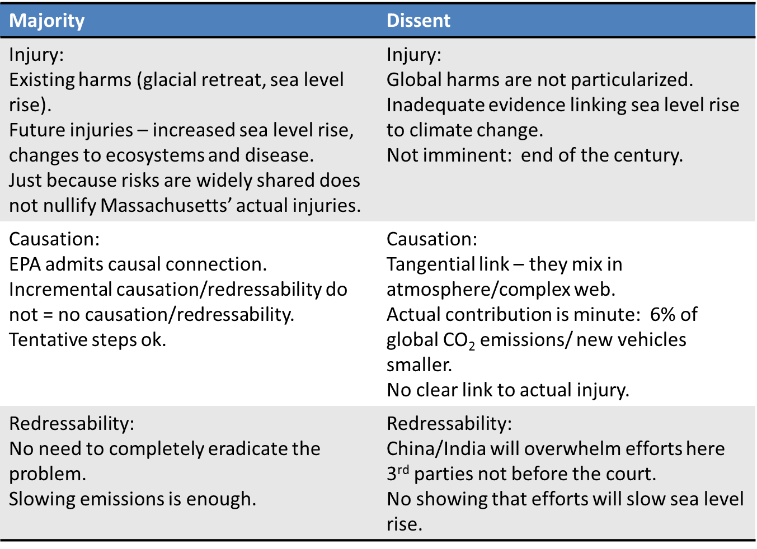
    - Questions raised by decision
      - How does parens patriae standing differ, if at all, from Art. III standing?
      - Does the “special solicitude” language in Massachusetts mean that private parties will not have standing?
      - Does standing depend on procedural v. substantive rights?
      - Will standing depend on the statute/law at issue?
      - Will prudential standing limitations apply to climate change?
  - Washington Environmental Council v. Bellon (9th Cir.)
    - Private entities bringing suit similar to Mass. v. EPA
    - Causal links too attenuated; special solicitude afforded MA not applicable to private parties
- Dormant Commerce Clause
  - Tests
    - Whether law discriminates against interstate commerce (protectionism)
    - Whether law places undue burden upon interstate commerce
    - Whether law attempts to regulate extraterritorial commercial conduct
  - Facial discrimination/protectionism
    - If there is a less discriminatory way of advancing state interests, then the law is invalid
    - City of Philadelphia v. NJ- whether NJ law banning import of solid waste from outside the state violated Commerce Clause
      - Out-of-state waste was indistinguishable from in-state, which was still allowed to be generated and deposited in landfills; if all deposits of waste (regardless of their origins) was banned, then the law would’ve been constitutional
      - Facial discrimination is per se invalid
    - Rocky Mtn. Farmers Union (9th Cir.)- challenge to California Low Carbon Fuel Standard (requiring a 10% reduction in carbon intensity of transportation fuels)
      - LCFS used lifecycle analysis to determine carbon intensity of biofuels; certain out of state producers used fossil fuel generation in refining and their biofuels were given lower rating
      - Out of state producers alleged they were being discriminated against and regulated by CA law (through lifecycle analysis)
      - Court found that LCFS only incidentally implicated regional origins of fuels; fuels were considered differently because of variables not associated with their origin
  - Undue burden
    - Pike v. Bruce Church, Inc.- if a state law regulates evenhandedly to effectuate legitimate public interest, it will be upheld so long as the burden imposed on interstate commerce is not excessive in proportion to putative local benefits
      - Balance nature of local interest against burden
      - Consider whether the interest can be furthered by less burdensome means
    - Practically, this is a lenient standard; it is not difficult for states to argue that state interests require a burden on interstate commerce
  - Extraterritorial regulation
    - Historically relegated to challenges to price affirmation statutes (requiring companies states to offer identical prices in-state and out-of-state)
    - EELI v. Epel (10th Cir.)- challenge to Colorado’s RPS
      - Coal industry argued that it regulated out-of-state coal plants
      - Court determined that RPS did not directly regulate prices
    - North Dakota v. Heydinger (8th Cir.)- challenge to Minnesota rule proscribing import of power/long-term PPAs which would result in increased statewide power sector CO2 emissions
      - Conflicted with MISO market structure; higher emitting sources could not feasibly be distinguished after sales were completed
      - Majority stated that the law effectively banned all coal-based power purchases across the MISO system (not just Minnesota)
    - Question remains how broadly SCOTUS will apply test
Renewable energy policy
- Tax credits: investment and production tax credits (ITCs and PTCs)
  - Require that beneficiary have a tax obligation in order to take advantage of credit
  - ITCs are based on cost of project; vary according to type of facility
    - Solar, small (<100kW) wind projects- thirty percent
    - Geothermal- ten percent
    - Everything becomes ten percent by 2023
    - Requires that facility be placed in service by the end of 2016
  - PTCs are based on energy produced
    - 2.3 cents/kWh for wind, geothermal, closed-loop biomass
    - .75 cents/kWh for others
    - Credits last for ten years after facility placed in service (i.e., contract signed and five percent invested)
    - Will become void by beginning of 2017
- Tax equity investors- allows renewable energy firms to sell their tax credits to third parties (usually banks or other firms with large tax obligations)
  - Exposes renewable energy firms to market fluctuations
  - Allows for greater liquidity
- Treasury grants- guaranteed federal loans to renewable energy firms
  - Defunct program
- Renewable portfolio standards (RPSs)
  - Mandates, imposed by state PUCs, which require utilities to obtain a certain amount of energy from certain sources
  - What qualifies as renewable is up to state legislatures
  - Renewable energy credits (RECs)
    - Associated with power created from renewable sources
    - Bundled RECs
      - Accounting and tracking tool
      - Follows and is attached to the power through consumption
    - Unbundled RECs
      - Separate commodity from power produced
      - After the REC is unbundled, the power ceases to be considered “renewable” for the purpose of fulfilling RPS (is null)
      - Tradable amongst utilities; fungible
    - Multipliers- different sources of renewables have different REC values
    - Example of REC- 003-001-121010-105
      - 003=facility ID; 001=category of facility; 121010=date of production; 105=which kWh or MWh produced on that date
  - Carve-outs- mandates a proportion of RPS requirement come from specific sources
- Public Utility Regulatory Policies Act (PURPA) (1978)
  - Required that utilities purchase and sell power to qualifying facilities (QFs); required that utilities allow QFs access to transmission; required utilities pay QFs avoided costs for power
  - Qualifying facilities- small (<80MW) renewable energy projects, cogeneration fossil-fuel plants
  - Avoided costs- amount utility would pay for power if not from QF; determined by PUCs
    - Determined, generally, through supply and demand (low supply and high demand would create a high price for that power)
    - Some states set avoided cost rates at prohibitively low levels, thereby dis-incentivizing construction of QFs
- Feed-in tariffs
  - Requires utilities to purchase power from renewable projects, connect them to grid
  - Requires utilities to pay incentive rates to renewable projects; limited by FPA to wholesale rates (avoided cost rates)
- Net metering
  - Allows distributed generation facilities (i.e., retail utility customers) to be paid retail price for power production
  - Retail rates limited to the amount of power consumed by retail customer; any power produced beyond that (where a retail customer produces more power than it consumes) may be purchased by utility at wholesale or avoided cost rates
    - Most states do not require utilities to purchase this excess power
Future
- CoP 22- Marrakech
  - Quick ratification of Paris Agreement, US election put parties on their heels
  - Uncertainty reigns
- Carbon budgeting
  - Finite amount of carbon based energy sources available for use based on keeping warming below 2^
- The Danish Model
  - 100% electricity and heat from renewables by 2035; 100% renewable energy by 2050
  - Wind turbines, a fuck ton of them
  - District heating- using centralized solar, combined cycle heating
    - Centralized system dispensing hot water, heat to homes in the winter

